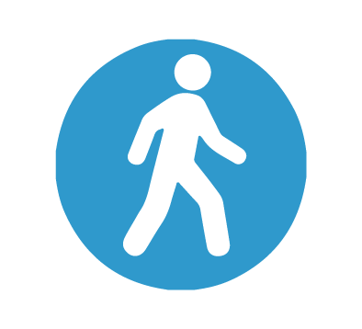

**64**

**Were NOT attended. These could have been offered to other patients.**

**3079**

**Were**

**attended**

**In July 2025 we had 3143 booked appointments.**

Visit the practice in person

Email **bnssg.wellingtonroad@nhs.net**

Call us on **01454 323366**

Text back to your reminder message

If you are unable to attend **always** cancel your appointment

**100%**